K-means clustering:

In our project, we analyze the heart beat data of the user collected and applied k-means algorithm on the data to get the clusters of heart rate. The corresponding R-code and g

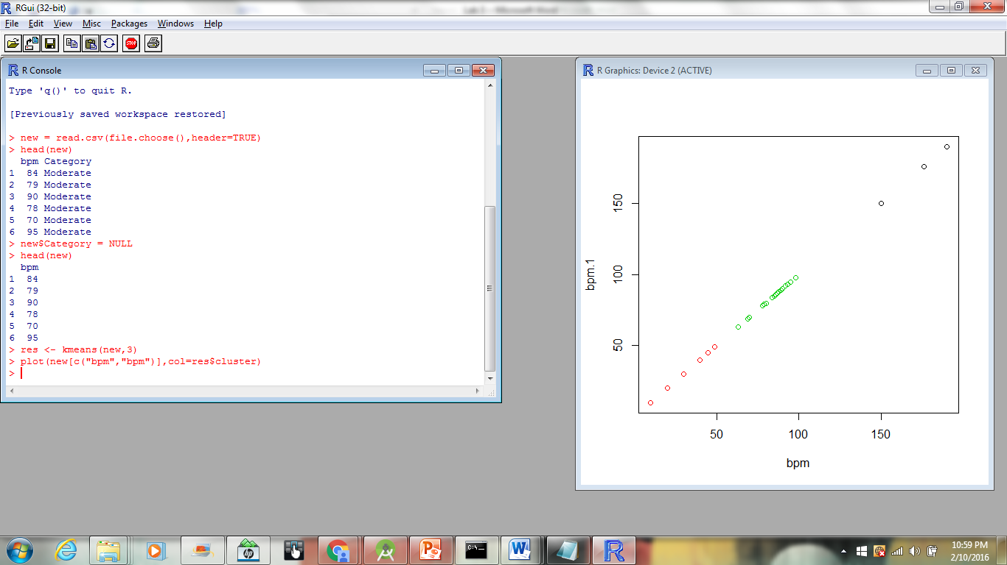

Hierarchical Clustering:

In hierarchial clustering, we are building an analysis of clustering, in which heart beat clusters are built in hierarchy.

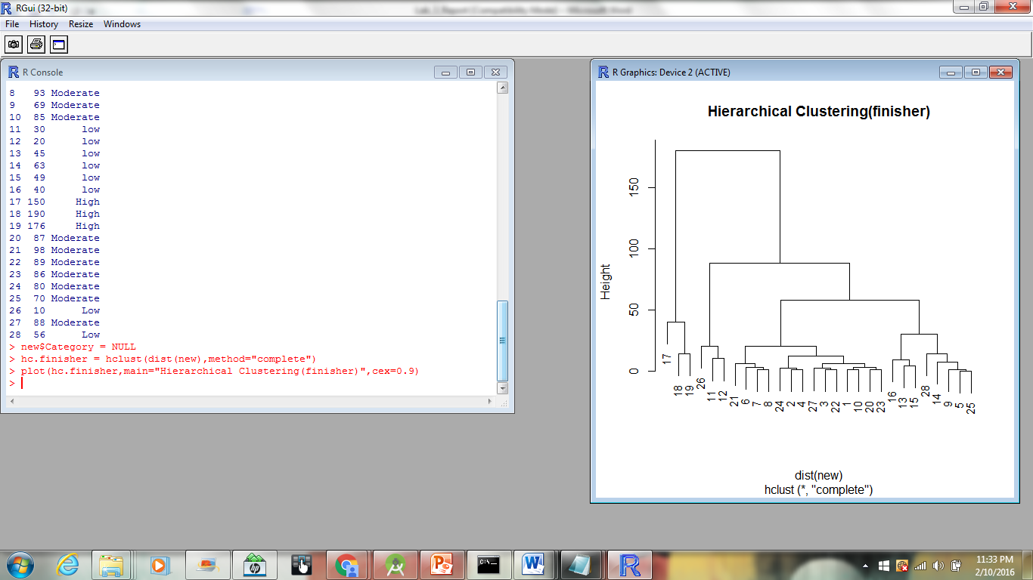

K-Medoids:

It is an algorithm which is related to both k-means and medoids. Both these algorithms aim at minimizing the distance between centroids. It’s a method in which n objects are divided into k-clusters.

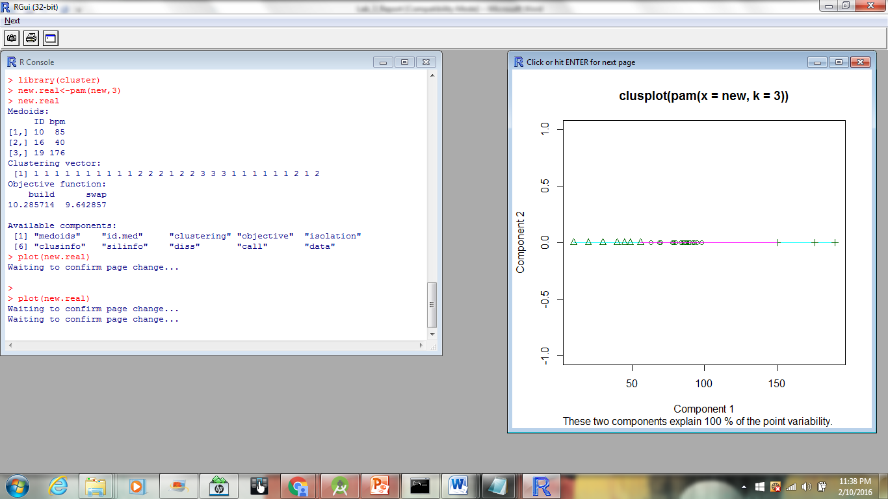

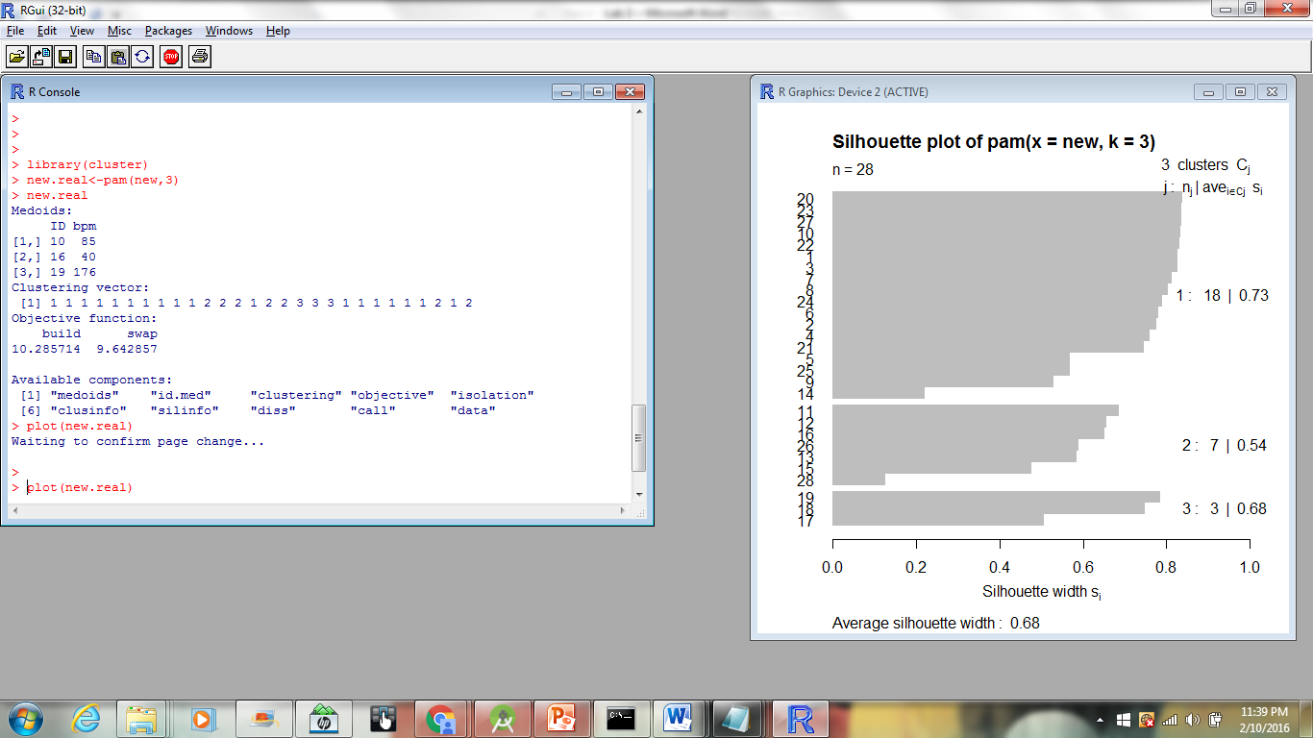

4. Expectation Maximisation:

It is an iterative method for finding maximum estimates of parameters in statistical models.  These parameter-estimates are then used to determine the distribution of the latent variables in the next E step.

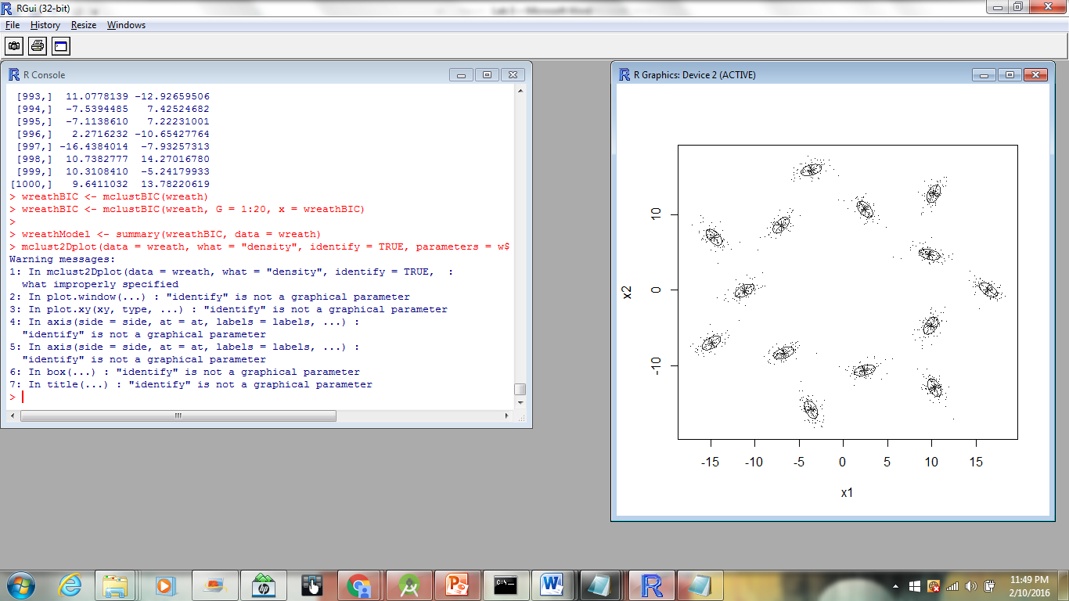

**Heart Rate Monitoring:**

In our project, we analyze the heart beat data of the user. So, we collected the heart rate data and steps walked.

Below is the screen shot taken after deploying the application and collecting the results.

